Structured Output:
When you want model to reply in specific format then this is used, in below example which is created for Cinema booking or cancel request, everytime when model receives request from customer, it is not guarantee, we get reply in specific format
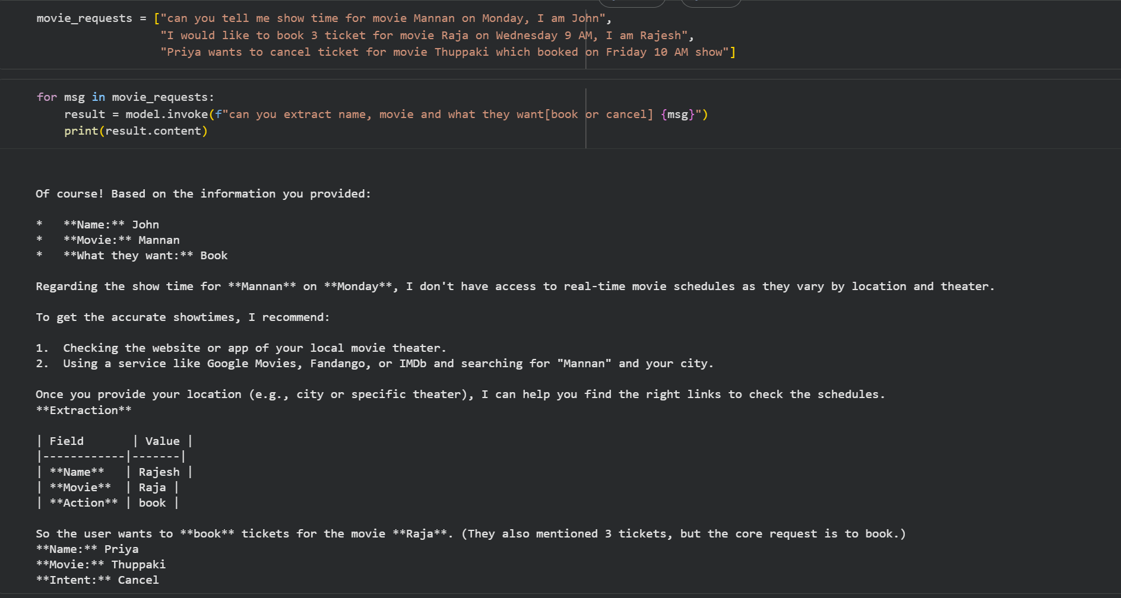

2 strategy:
Tool strategy - it fakes via a synthetic tool call, works always but slow
Provider strategy – langchain automatically uses provider strategy when schema is directly passed to create_agen.response_format and the model supports native structured output
Response would be fast but woks only when it is supported
CineBot

Agent Model
.with_structured_output
Response_format

In short, when you use .with_structured_output in model or response_format in agent(provided model support structured output ) means it is provider strategy
For tool strategy, it is used only at agent level when model not supported structured output
Tool strategy is not for tool to call, it is meant only for structured output when model structure output is not supported

